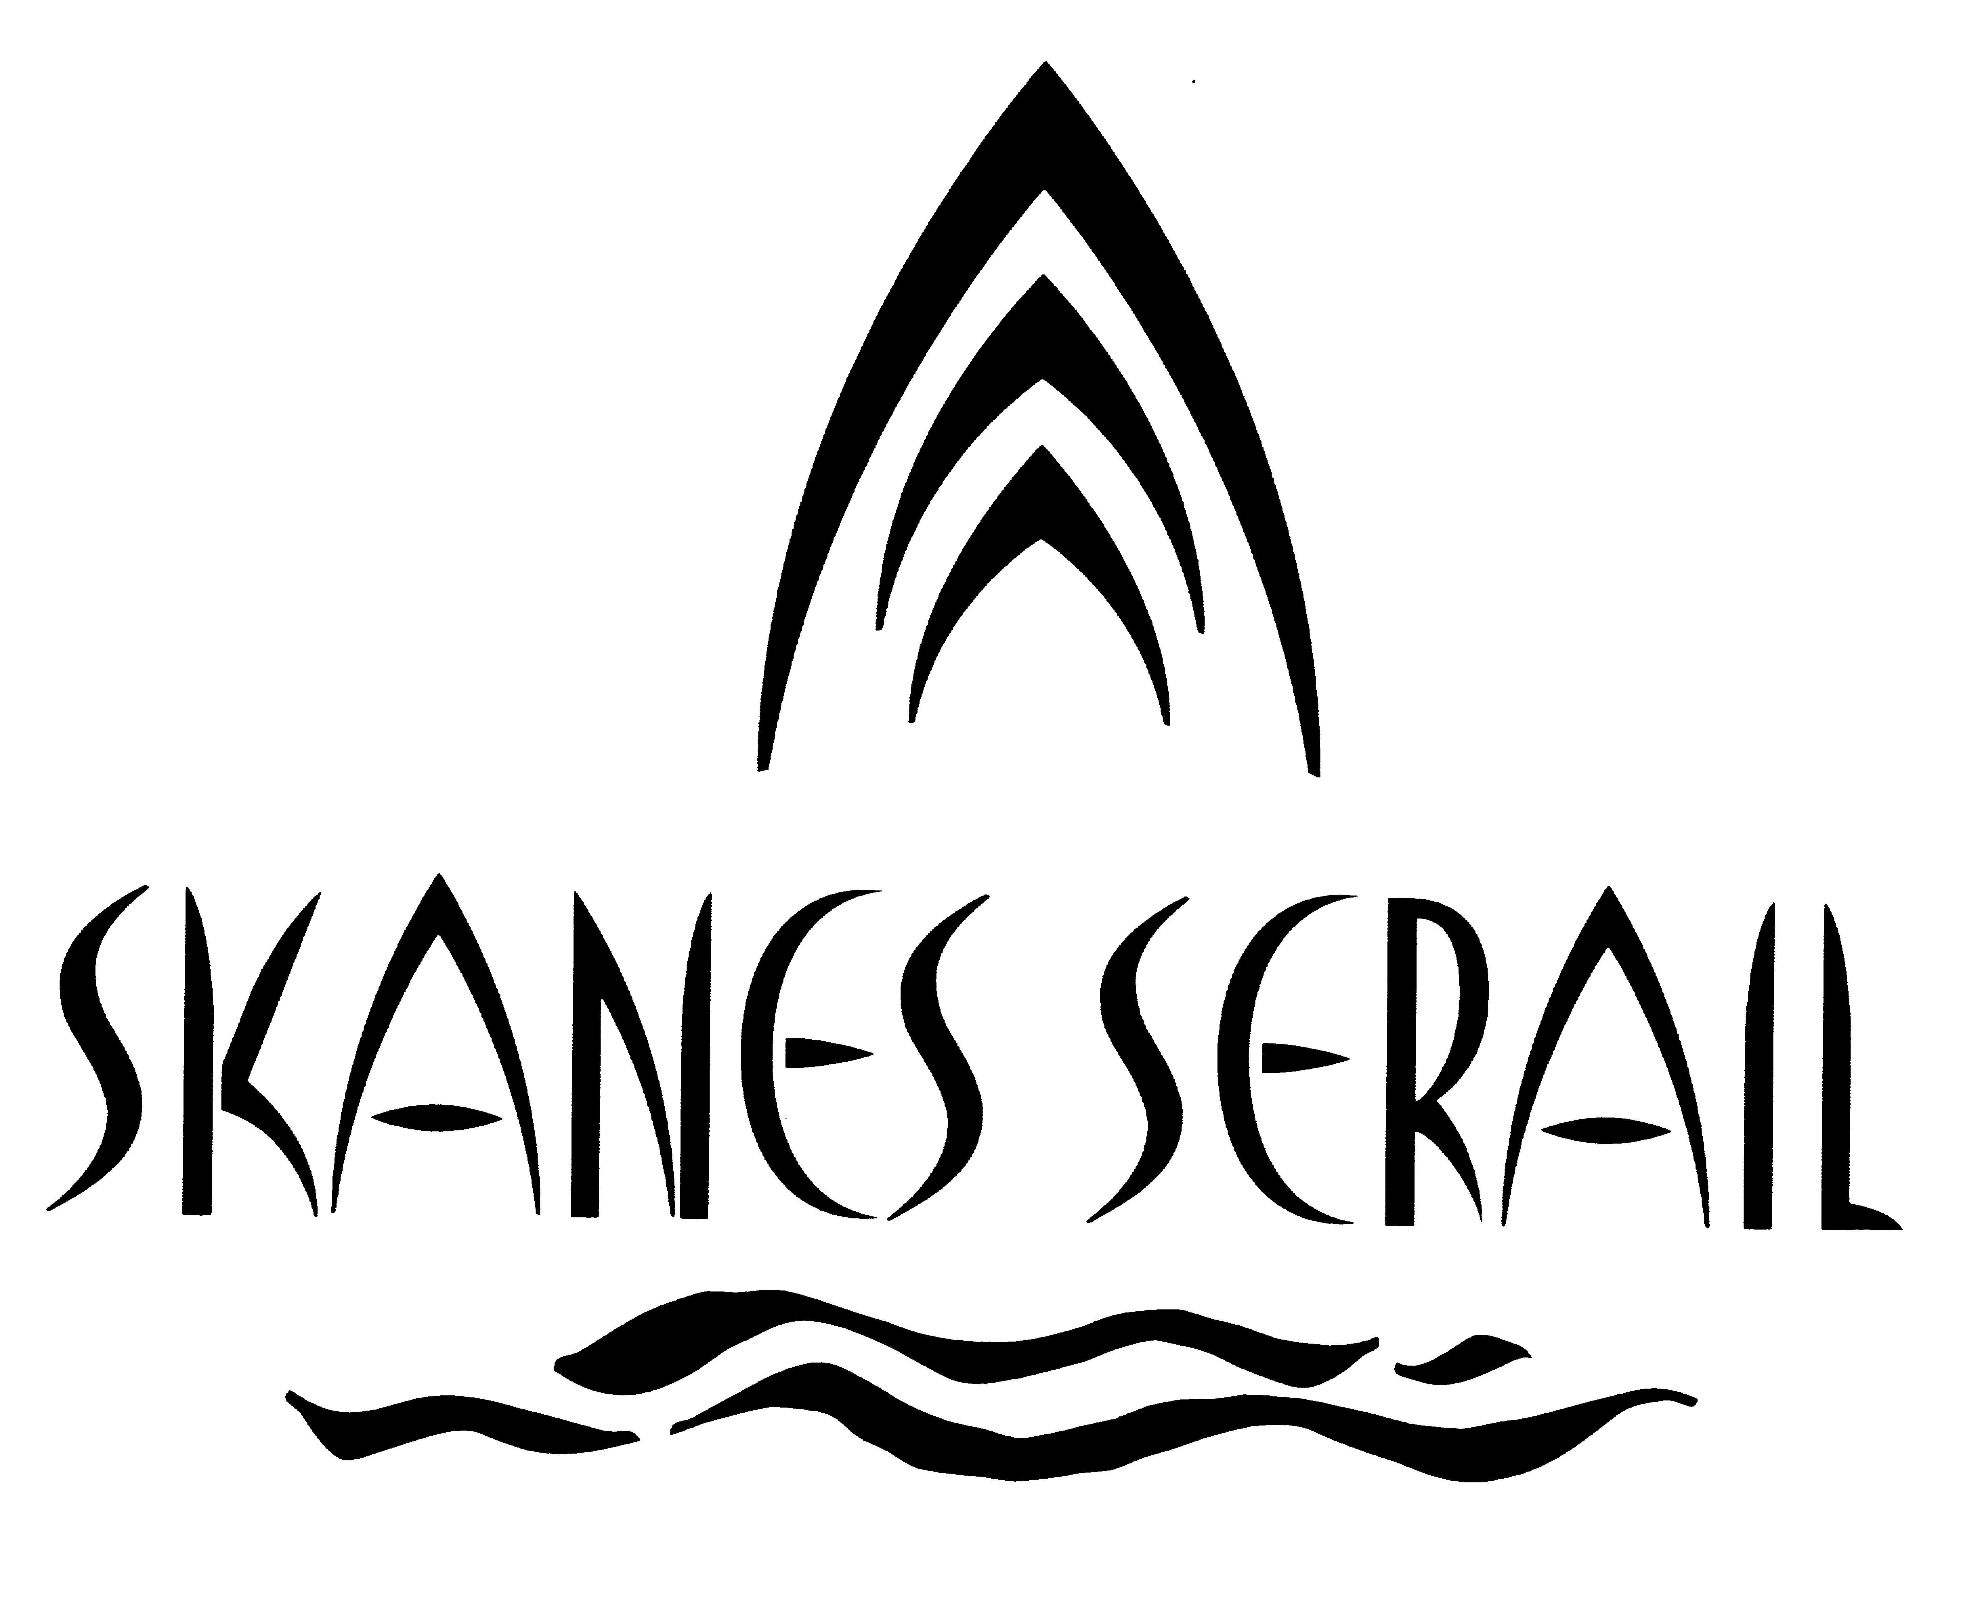

SITUATION :
Situated aboard a magnificent private beach, Skanes Sérail wants to be the place of all your pleasures by providing you with its luxurious 224 rooms and suites, his Restaurants and Bars in the felted atmospheres, his SPA center distinguished by its design conceived for your comfort and the neighborhood of 02 golf courses to decorate your holidays.
LOCATION:
- In the tourist zone Skanes Monastir
- Aboard its own beach deprived
-In 6 km of the city center of Monastir
-In 12 km of the city center of Sousse
- In 3 km of two golf courses
-In 2 km of the International airport of Monastir
-In 145 km of the International airport of Tunis Carthage
Accommodation
224 luxurious rooms and suites distributed as follows:
- 60 communicating room (30m²)
- 20 quadruple rooms for family accommodation (34m²)
- 9 suites with separate lounge (40m²)
- 1 ministerial suite: two bedrooms plus lounge and dining room (90 m²)
- 78 of the rooms have a sea and swimming pool view, 60 rooms have a sea view, 76 rooms have a garden view (30m²)
- All the rooms are endowed with bathtub and hair dryer
- telephone with wake up service
- Satellite T.V
- Balcony in all the room
- Mini Bar on request (with extra charge 08 TD/day)
- Safe Deposit Box (DEPOSIT )
- 3rd and 4th bed and Baby cot are available
Restaurants et Bars :
- Main Restaurant « Le Sultan », serving an international cooking on buffet style
- A la Carte Restaurant « L’Emir »
- BBQ Restaurant « Le Neptune» aboard of the beach (during summer )

- Piano Bar et Moorish Coffee “Chahrazed”
- Pool Bar “ Sindbad” ( during summer season )
- Beach Bar « Aladdin » (during summer season)
Conférences room
Nbr | H | length | width | Surf m2 | Surf m2 | Cinema | Class | Diner | Cocktail
Conference Hall | 1 | 7m | 23m | 15m | 350m² | 320 | 100 | 200 | 280
Meeting Room  ( A la Carte Restaurant) | 1 | 5m | 10m | 12m | 120m² | 100 | 40 | 70 | 70
Suite for Subcommittees | 3 | 3m | 6m | 4m | 24m² | 25 | 10 | 20
Covered Terrace | 1 | 4m | 25m | 10m | 250m²

Others services :

☒2 Swimming pool ☒Billard
☒diving ☒Mini-club 4-12
☒Aerobic ☒Water polo ☒Beach foot
☒Ping Pong ☒shop
☒2 golf courses nearby ☒Amphitheatre
☒Animation
☒ Riding center (5 minute) ☒diving center ( 10 minute ) ☒Beach volley
☒aquapark

☒Indoor swimming pool ☒Jacuzzi
☒Massage ☒children‘s playground ☒Barbecue
☒Vaporium ☒spa center

General conditions

3 floors

2 lifts

Air conditioning from 15 June to 15 September

Free parking

Luggage

Shops

Babysitting (extra charge)

Laundry (paying)

Exchange and Credit cards accepted: Master Card, Visa

Electricity: 220V - 50Hz

Sports & Activity:
Aquapark ;Quick; playground & Mini-Club for children (04-12 years), tennis table, Beach-volley, indoor swimming pool (winter), Terrain: Football, Handball, Aerobic, Gym , Water Polo, Beach soccer, Jacuzzi.

Extra charge
, Hammam/ Vaporium –massage, diving, Skateboards, Sailing, Pedalo, Canoe Jet Ski
Water Ski, Parachute, Banana, Boat trip; Games & Billiard video, Laundry Services

Hôtel "Skanes Serail" BP 23 – 5065 Skanes Monastir Tunisie
Tél: (00216) 73 520 240 Fax: (00216) 73 520 234
E-Mail : skanes.serail@planet.tn Web : www.hotelserail.com

