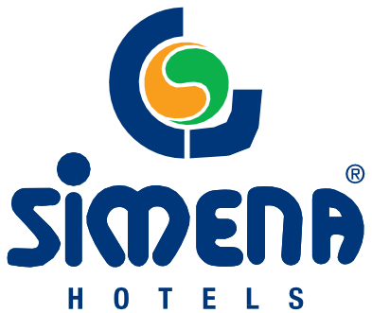

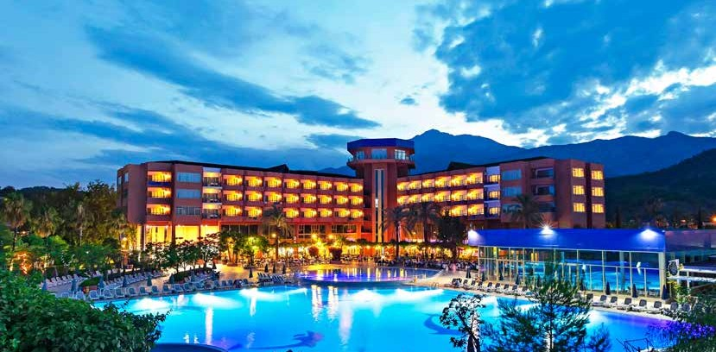
SIMENA HOTEL

FACT SHEET & CONCEPT 2022 SUMMER

www.simenahotels.com



SIMENA HOTEL
Opening date | May 1999 | Address | Turizm Bulv.No:23 Çamyuva/Kemer
Category | Hotel | City | Antalya - Turkey
Company | Ceytur Ceylan Tur.İşlt.San.Tic.A.Ş. | Phone | +90 242 824 63 63 (18 lines)
Investor | Abdullah Ceylan | Fax | +90 242 824 63 81
General Manager | Günaydın Atar | E-mail | info@simenahotels.com
Season | 01 April - 31 October 2022 |  | sales@simenahotels.com
Total area | 160.000 sq.m. | Web site | www.simenahotels.com
Concept | Ultra All Inclusive | Antalya airport | 65 km
Beach | private beach | Antalya city centre | 55 km
Languages | Turkish-English-German-Russian | Nearest city centre | Kemer / 7 km
Credit cards | Visa-Mastercard-Eurocard | Transportation facilities | VIP transfer, bus, taxi (paid)
Pets | not allowed | Voltage | 220 Volt

ACCOMMODATION CAPACITY AND ROOM INFORMATION
Total number of rooms | 304
Total number of beds | 744
HOTEL NAME | SIMENA HOTEL |  | VILLAS
Room type | Hotel Standart | Hotel Delux Suit |  | Villa Superior Standart | Villa Superior Garden Suit | Villa Superior Junior Suit | Villa Standart Room | Villa  Garden Room | Villa Garden Suit | Villa Family Suit | Dublex Villa 400 m2 | Dublex Villa 200 m2
With land view | 66 | 7 |  | 40 | 16 | 7 | 56 | 10 | 13 | 10 | 4 | 14
With pool view | 52 | 6
Disabled-friendly rooms | 3
Total number of rooms | 121 | 13 |  | 40 | 16 | 7 | 56 | 10 | 13 | 10 | 4 | 14
Area sq.m | 36 m2 | 72 m2 |  | 30 m2 | 45 m2 | 55 m2 | 25 m2 | 40 m2 | 45 m2 | 55 m2 | 400 m2 | 200 m2
Number of bedrooms | 1 | 1 |  | 1 | 1 | 1 | 1 | 1 | 2 | 2 | 4 | 2
Number of living rooms | 0 | 1 |  |  |  |  |  |  |  |  | 2 | 1
Min./Max. pax | 1/3 | 1/4 |  | 1/3 | 1/4 | 1/4 | 1/2 | 1/3 | 1/4 | 1/4 | 1/10 | 1/6
Hair dryer | X | X |  | X | X | X | X | X | X | X | X | X
Split air conditioner | X | X |  | X | X | X | X | X | X | X | X | X
Telephone | X | X |  | X | X | X | X | X | X | X | X | X
Electronic safe | X | X |  | X | X | X
Satellite TV | X | X |  | X | X | X | X | X | X | X | X | X
Minibar (soft drinks) | X | X |  | X | X | X | X | X | X | X | X | X
Electronic key | X | X |  | X | X | X |  | X | X

FOOD AND BEVERAGE SERVICE
RESTAURANTS |  | SERVICE | HOURS | DATE
Main restaurant | Breakfast | Open buffet | 07:00-10:00 | 01.04-31.10.2021
Main restaurant | Late breakfast | Open buffet | 10:00-11:00 | 01.04-31.10.2021
Main restaurant | Lunch | Open buffet | 12:30-14:30 | 01.04-31.10.2021
Main restaurant | Dinner | Open buffet | 19:00-21:30 | 01.04-31.10.2021
Main restaurant | Night meal | Open buffet | 23:30-00:30 | 01.04-31.10.2021
A la carte restaurants | Ottoman, Italian, Sea food | Please note that service fee per person is charged at a la carte restaurants and reservation is to be made one day before your visit, there is no charge for children aged 2-2 | 19:00-21:30 | 01.04-31.10.2021
Snack restaurant | Snacks & Beverages | Open buffet /Snack varieties and beverage service | 11:30-16:00 | 01.04-31.10.2021
Pastry corner | Pastry & Beverages | Open buffet /Pastry varieties and beverage service | 16:00-17:00 | 01.04-31.10.2021
Ice-cream corner | Ice-cream | Ice-cream varieties | 13:00-16:00 | 01.04-31.10.2021
Beach snack restaurant | Snacks & Beverages | Snack varieties and beverage service | 11:30-16:00 | 01.04-31.10.2021
Villa Pool Bar 1 | Snacks & Beverages | Snack varieties and beverage service | 11:30-16:00 | 01.04-31.10.2021
Room service | Food & Beverages | Menu / paid | 24 saat | 01.04-31.10.2021

BARS | SERVICE | HOURS | DATE
Lounge Bar | Cold-hot drinks and appetisers are served | 09:00-00:30 | 01.04-31.10.2021
Pool Bar | Cold-hot drinks and appetisers are served | 10:00-23:00 | 01.04-31.10.2021
Beach Bar | Cold-hot drinks and appetisers are served | 11:30-16:00 | 01.04-31.10.2021
Snack Bar | Cold-hot drinks and appetisers are served | 11:30-16:00 | 01.04-31.10.2021
Disco Bar | Cold-hot drinks and appetisers are served | 23:00-00:30 | 01.04-31.10.2021
Villa Pool Bar 1 | Cold-hot drinks and appetisers are served | 10:00-17:00 | 01.04-31.10.2021
Villa Pool Bar 2 | Cold-hot drinks and appetisers are served | 10:00-17:00 | 01.04-31.10.2021
- All non-alcoholic drinks, local drinks and some foreign alcoholic drinks are included in the concept.
- Drinks are served to the table only in our a la carte restaurants.
- Minibars in the room are filled with water and soft drinks only on the day of arrival, water is renewed every day.
- Ice cream service hours may vary by the decision of hotel management depending on the season, guest profile and product supply.
- Opening and closing hours and locations of bars and restaurants can be changed by hotel management according to weather and seasonal conditions.
- From 00:30 to 03:00, alcoholic drinks at the Lounge Bar are paid.

HONEYMOON SERVICES | PAID | FREE OF CHARGE
Special themed decoration of the room and ribbon decoration of the door are made for our honeymoon couples. |  | X
Sparkling wine, special treats and bathrobes in the room on the day of arrival. |  | X
A meal at our a la carte restaurant and a cake with special design to your table after the meal. | X
A specially prepared massage package for honeymooners in our SPA. | X
Private airport-hotel-airport transfer. | X

ANIMATION, ENTERTAINMENT AND SPORTS ACTIVITIES
- Daytime activities, tournaments, pool games, water ball, gymnastics, step, dance lessons, beach volleyball, volleyball and basketball.
- Evening animation programmes, show groups on certain days of the week, live music performances, stage performances and competitions.
- Fitness hall, table tennis, darts and tennis.
- There are 7 tennis courts. The courts can be used free of charge. Lighting, rackets and private lessons are paid.

KIDS CLUB
- Our Kids Club is open 10:00-12:30/14: 30-17:00 and renders services to children from 04 to 12 (with reservation)
- Children from 01 to 04 are to be accompanied by their parents.
- Weekly children’s shows with the participation of children based outdoor games and children’s playground.
- Weekly special birthday parties.
- Minidisco in the evening every day of the week.

SPA
- Turkish bath, sauna, indoor pool, therapy rooms and relaxation area are free of charge.(with reservation)
- Massages, Turkish bath services, skin and body care, and Spa Beauty shop services are paid.(with reservation)
- Our SPA area is run by a private company.

BEACH
- The beach is 250 m away from Simena Hotel and 500 m away from Simena Holiday Village, the beach is mixed sand and pebbles.
- Umbrellas and sun loungers are provided free of charge.

SWIMMING POOLS
SWIMMING POOLS | Outdoor | Indoor | Depth, cm | Area m2 | Soft water | Heated
HOTEL SWIMMING POOL | X |  | 160 cm | 2350 m2 | X
HOTEL POOL FOR CHILDREN | X |  | 40 cm | 180 m2 | X
HOTEL INDOOR POOL |  | X | 160 cm | 280 m2 | X
HOTEL INDOOR POOL FOR CHILDREN |  | X | 30 cm | 10 m2 | X
VILLA POOL - 1 | X |  | 160 cm | 425 m2 | X
VILLA POOL FOR CHILDREN - 1 | X |  | 30 cm | 30 m2 | X
VILLA POOL - 2 | X |  | 150 cm | 114 m2 | X
VILLA POOL FOR CHILDREN - 2 | X |  | 30 cm | 28 m2 | X
There are two water slides in the outdoor swimming pool of the hotel.

CONFERENCE AND MEETING HALLS
HALL NAME
WIDTHLENGTH
M2
HEIGHT
BANQUETTE
CLASS
THEATRE
RECEPTION
LYKIA
18,10 m
18 m
362 m2
3,50 m
160 pax
150pax
200 pax
320 pax
PANOROMA
13,50 m
14 m
160 m2
3,20 m
80 pax
72 pax
100 pax
150 pax
Hall equipment: wireless microphone, wired microphone, barcovision screen, sound system, flip chart.

OTHER SERVICES
SERVICES | EXPLANATION | PAID | FREE OF CHARGE
OUTDOOR PARKING | AVAILABLE / WITH DEFINITE CAPACITY |  | X
LAUNDRY AND IRONING SERVICES | FROM 09:00 UNTIL 16:00 | X
SPECIAL TRANSFERS / TAXI | AVAILABLE / RUN BY A PRIVATE COMPANY | X
WIRELESS INTERNET CONNECTION | AVAILABLE / GENERAL PREMISES |  | X
BEACH TOWELS | THE TOWEL EXCHANGE IS PERFORMED ONCE A DAY WITH A TOWEL CARD |  | X
SUN LOUNGERS AND UMBRELLAS |  |  | X
PHONE AND FAX |  | X
HAIRDRESSER |  | X
DOCTOR AND NURSE |  | X
BOUTIQUE AND MARKET |  | X
LEATHER AND JEWELLERY STORES |  | X
PHOTOGRAPHER |  | X

GENERAL CONCEPT PRINCIPLES
- In accordance with local laws, alcoholic drinks are not served to guests under 18 years of age.
- The hotel management reserves the right not to serve alcoholic drinks to guests after a certain alcohol consumption and when they can do harm to themselves or those around them.
- The check-out time is 12:00. During the check-out process, the room key, the guest’s wristband and the towel card must be returned to the reception.
- On the check-in day, the accommodation and all other services within the concept can be used by the guest starting from 14:00.
- For late check-out and early check-in extra fee is charged
- Please note that if food and beverages served within the territory of the hotel facility are taken to the rooms, the guests are extra charged.
- Beach, pier and water slides are open for use according to weather conditions.
- Dry cleaning service is not provided within the hotel facility. Our hotel facility is not responsible for any problems that may occur within the scope of this extra paid service provided by third-party companies.
- In accordance with local laws, smoking in indoor premises (rooms, lobby, restaurants etc.) is forbidden. Otherwise, such cases are subject to financial penalties determined by local authorities.
- The use of personal devices such as hookahs, electronic cigarettes etc. in the rooms is not allowed.
- All damages caused by the guest, including damages caused by the use of such devices in the room and hotel, will be charged to the guest.
- The children can use water slides, pools and activity areas only if accompanied by their parents.
- Any health problems of our guests caused during their individual trainings in the Fitness Centre are under their own responsibility.
- The safe boxes in your rooms are provided for your valuables free of charge . Our hotel facility bears no responsibility for any lost items.
- Wristbands are used in our hotel for safety reasons and for our guests to benefit from the services offered. If the wristband is lost, extra fee is charged.
- The services provided within our hotel facility by private companies do not belong to the hotel and the hotel management does not bear any responsibility in this regard.
- Pest control and disinfection measures are taken regularly in our hotel facility in accordance with international quality standards.Parties, animation programmes and all other activities can be changed or cancelled according to weather conditions, guest profile, season and physical factors.

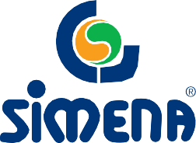



Turizm Bulv. No: 23 Çamyuva / Kemer Antalya- TÜRKİYE • T+90 242 824 63 63 • info@simenahotels.com
www.simenahotels.com





