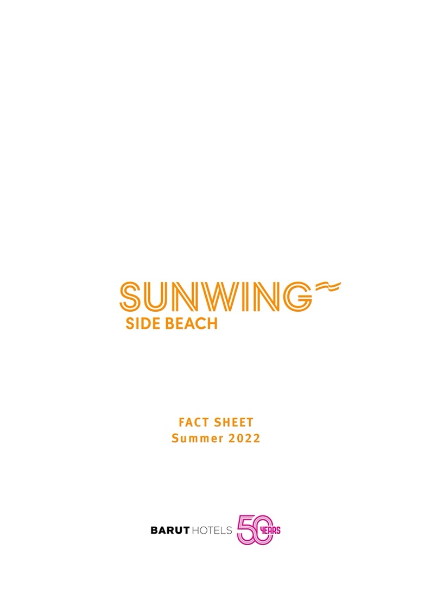

The infinite Holiday, In the Heart of The Mediterranean!!
Sunwing Side Beach by Barut Hotels, the new recipe for peace and fun, offers a memorable Mediterranean experience with a concept designed to delight every member of the family..04.2020 / 31.10.2020

GENERAL INFORMATION



Hotel Name | Sunwing Side Beach
Category | 4* Hotel
Location | Side – Antalya
Telephone | 0 (242) 753 69 00
Fax | 0 (242) 753 59 29
Web Site | www.sunwingsidebeach.com
E – Mail | sidebeach@baruthotels.com
Address | Adnan Menderes Bulvarı Side Cennetler Mevkii
Address | No:39 Manavgat - Antalya / TÜRKİYE
Total Area | 46,000 m2

Opening Date | 2012
Last Renovation | 2019 February
Consept | Room Only/Bed & Breakfast/Half Board/All
Consept | Inclusive
Beach Distance | 600 meter
Number of Rooms | 300
Beach | Sand
Number of Floors | 4 - 5
Internet / Wireless | Free troughout the Hotel and in the rooms.
Vailed Credit Cards | Visa, Master Card

DISTANCES AND TRANSPORTATION

Antalya Airport | 60 km
Antalya City Centre | 8 km - Manavgat
Side | 2,7 km
Transportation opportunities | Bus, Taxi, Minibus (Antalya-Side-Manavgat-Alanya)
Location and length of the beach | 100 meter lenght and 600 meters away from hotel.
Coastal Walking Trail | No
Closest hospital | Özel Anadolu Hospital - 4km

POOLS

Pool | Outdoor | Indoor | Fresh | Heated | Depth | Volume | Size
Pool | Area | Area | water | Heated | (cm) | (m3) | (m2)
Swiming Pool | • |  | • | • | 140 | 2880 | 2057
Kids Pool** | • |  | • | • | 60 | 1075 | 768
Baby Pool** | • |  | • | • | 30 | 35 | 15
Indoor Pool** |  | • | • | • | 140 | 347 | 248
Waterslides Pool** | • |  | • | • | 140 | 800 | 640

** The date and time of the operation of the units are determined by the hotel management according to seasonal conditions.

***The facility shall remain entitled to modify the service concept as based on the re solutions adopted by the World Health Organization, the Ministry of Culture and Tourism of the Republic of Turkey and the Ministry of Health of the Republic of Turkey and also the local authorities during the course of the normalization process implemented with respect to the Covid-19 by the Ministry of Culture and Tourism of the Republic of Turkey.

ROOMS

Room Type | Number of | m² | Features | Capacity
Room Type | rooms | m² | Features | Capacity
 |  |  | • 1 Bedroom with Kitchenette. Balcony included it is about 40 m².
 |  |  | • Bedroom has a bed for 2 person and there are 2 sofa.
 |  |  | • The Kitchenette has microwave oven, fridge, waterboiler, toaster
 |  |  | and oven.
Suite Garden View | 65 | 40 | • The maximum person capacity is 2 adults + 2 children or 3 adults +1 child. | Max. 2+2 or
Suite Garden View | 65 | 40 | • WC, shower, hair dryer, TV & Telephone. | 3+1 persons
 |  |  | • The Safe is free of charge.
 |  |  | • The Wifi connection has all around the hotel and free of charge.
 |  |  | • The Beach towel deliver in the room for per person.
• Coffe and tea ünits.
• The apartment cleaning is everyday.
 |  |  | • 1 Bedroom + 1 Kitchen with livingroom. Balcony or Terrace included
 |  |  | it is about 40 m².
 |  |  | • Bedroom has a bed for 2 person and there are 2 sofas in the
 |  |  | livingroom.
 |  |  | • The Kitchen has microwave oven, fridge, waterboiler, toaster and
 |  |  | oven. | Max. 2+2 or
Suite Sea Side | 80 | 40 | • The maximum person capacity is 2 adults + 2 children or 3 adults + | Max. 2+2 or
 |  |  |  | 3+1 persons
 |  |  | 1 child. | 3+1 persons
 |  |  | • WC, shower, hair dryer, TV & Telephone.
 |  |  | • The Safe is free of charge.
 |  |  | • The Wifi connection has all around the hotel and free of charge.
 |  |  | • The Beach towel deliver in the room for per person.
• Coffe and tea ünits.
• The apartment cleaning is everyday.
 |  |  | • 2 Bedrooms + 1 Kitchen with livingroom. Balcony included it is
 |  |  | about 50 m².
 |  |  | • First Bedroom has a bed for 2 person. Second Bedroom has 1
 |  |  | bunkbed or 2 single bed and there are 2 sofas in the livingroom.
 |  |  | • The Kitchen has microwave oven, fridge, waterboiler, toaster and
Grand Suite  Garden View | 5 | 50 | oven. | Max. 4+2 persons
Grand Suite  Garden View | 5 | 50 | • The maximum person capacity is 4 adults + 2 child. | Max. 4+2 persons
 |  |  | • WC, shower, hair dryer, TV & Telephone.
 |  |  | • The Safe is free of charge.
 |  |  | • The Wifi connection has all around the hotel and free of charge.
 |  |  | • The Beach towel deliver in the room for per person.
• Coffe and tea ünits.
• The apartment cleaning is everyday.

***The facility shall remain entitled to modify the service concept as based on the re solutions adopted by the World Health Organization, the Ministry of Culture and Tourism of the Republic of Turkey and the Ministry of Health of the Republic of Turkey and also the local authorities during the course of the normalization process implemented with respect to the Covid-19 by the Ministry of Culture and Tourism of the Republic of Turkey.

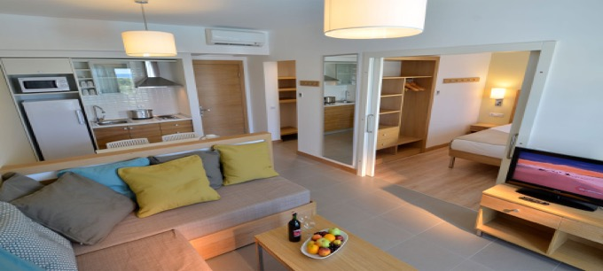

*Room Picture Suite Garden view

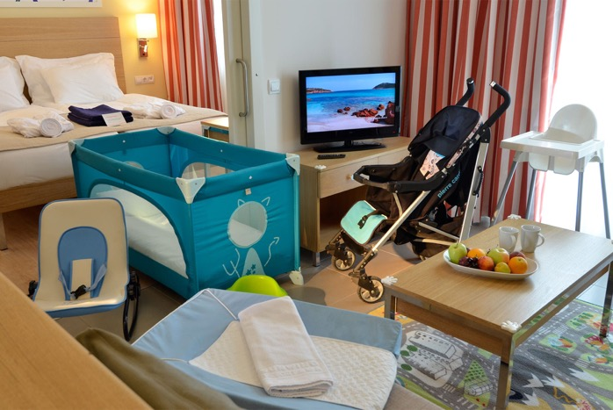

*Room Picture Suite Garden View (With Barystar concept)

Pets (cats, dogs, birds, etc.) are not allwed in our facility.

***The facility shall remain entitled to modify the service concept as based on the re solutions adopted by the World Health Organization, the Ministry of Culture and Tourism of the Republic of Turkey and the Ministry of Health of the Republic of Turkey and also the local authorities during the course of the normalization process implemented with respect to the Covid-19 by the Ministry of Culture and Tourism of the Republic of Turkey.

GASTRONOMY

Open Buffet & Main Restaurant

At Sunwing Side Beach, you will enjoy a high-quality dining experience with distinctive dishes that appeal to both your eyes and your palate. Our chefs carefully prepare each dish with pure Mediterranean flavours that sate your appetite without weighing you down in the heat of the summer. And, you can sample as much as you wish at our buffets.At our buffet restaurant you and your family during your enjoyable holiday having different World kitchen tastes also.Every night we would serve diffrent theamas.

Capacity: 650 pax.

Social Distance :485 pax

Breakfast (Open Buffet) | 07:30 - 10:30 | Buffet
Breakfast (Open Buffet) | 07:30 - 10:30 | Restaurant
Late Breakfast (Open Buffet) | 10:00 - 10:30 | Buffet
Late Breakfast (Open Buffet) | 10:00 - 10:30 | Restaurant
Lunch (Open Buffet) | 12:30 - 14:00 | Buffet
Lunch (Open Buffet) | 12:30 - 14:00 | Restaurant
A la Carte Lunch (Menu) | 12:00 - 15:30 | Mehmets Kıtchen
A la Carte Lunch (Menu) | 12:00 - 15:30 | Restaurant
A la Carte Dinner (Menu) | 18:00 - 21:30 | Fino Terrace & Grill
A la Carte Dinner (Menu) | 18:00 - 21:30 | Restaurant
Snack service | 12:00 - 16:00 | Beach Club
Snack service | 12:00 - 16:00 | (Snack) Bar,buffet
Coffe and Cake (Open Buffet) | 10:00 - 21:30 | Show Bar
Dinner (Open Buffet) | 18:30 - 21:00 | Buffet
Dinner (Open Buffet) | 18:30 - 21:00 | Restaurant
Dinner | 18:00 – 21:30 | Mehmets Kıtchen

**In accordance with the dress code and in consideration of other diners, guests wearing shorts, swimwear and slippers are not permitted at our restaurants.

- The date and time of the operation of the units are determined by the hotel management according to seasonal conditions.

COFFE SHOP

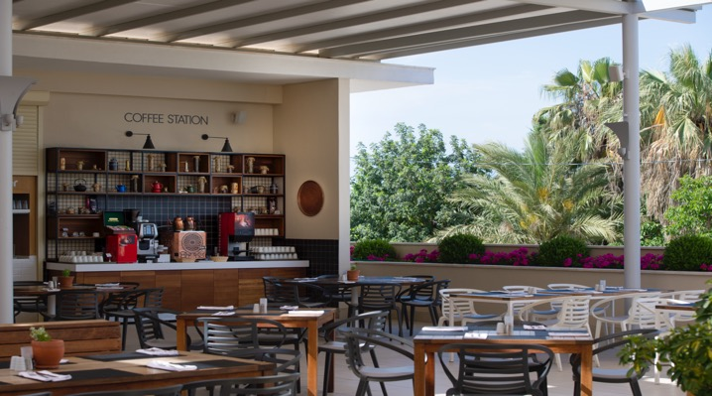

***The facility shall remain entitled to modify the service concept as based on the re solutions adopted by the World Health Organization, the Ministry of Culture and Tourism of the Republic of Turkey and the Ministry of Health of the Republic of Turkey and also the local authorities during the course of the normalization process implemented with respect to the Covid-19 by the Ministry of Culture and Tourism of the Republic of Turkey.

À LA CARTE RESTAURANT **

Fino Terrace & Grill Restoran

Opening Hours:

18:30 – 22:00 Dinner

Capacity: 85 persons Social Distance :63 pax

Inspired by the tranquil blues of the Mediterranean and overlooking a sparkling pool, the Terrace & Grill offers the most distinctive flavours in world cuisine. Reservations are required for dining in this à la carte restaurant.

Sunwing Side Beach family friendly restaurant offers an extensive dinner menu with options for every age group.

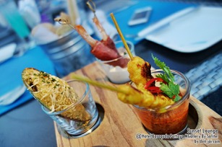

BARS **

LİME BAR&SHOW BAR

Opening Hours : 10:00 – 01:00

Take time to enjoy a healthy drink under the sun’s rays, and have a dip in the shimmering waters of the refreshing pool. We offer cocktails, fresh fruit juices, and alcoholic and non-alcoholic beverages, as well as a selection of ice cream. So, sit back and cool off. Enjoy the carefully prepared cocktail menu in the bar, where complimentary ice cream, filter coffee and cookies are served from 10:30 to 22:00 for all-inclusive guests.

SUNSET LOUNGE BAR
Opening Hours : 18:00 – 00:00

The stylish Sunset Lounge, which begins service during the evening hours, colours your holiday with a magnificent view, in addition to local and foreign, alcoholic and non-alcoholic drinks. From the Sunset Lounge, you can observe Ancient Side or thespecial performances in the show area, visible from the Lounge

At dinner, a candle-lit table invites you to relax and enjoy the dining experience ahead. You can start with mezes, and then sample our restaurant’s specialities, perhaps accompanying your meal with a lovely win,all inclusive guest would have % 15 dıscount on food and beverages.

*Fino alacarte is subject to charge and requires reservatıon.

MEHMET’S KITHCEN
Lunch : 12:00 – 15:30 Capacity: 228 pax.
Dinner : 18:00 – 21:30 Social Distance :170 pax
Mehmet's Kitchen Restaurant, featuring the traditional tastes in Turkish cuisine, takes you on a gourmet journey with the creative presentations of master chefs. The restaurant, where you will find a delicious range of kebabs, pitas varieties, meat dishes and salads, is subject to an extra charge for all guests. The restaurant also features a Lollo & Bernie buffet, free of charge for children under 12 years old.All İnclusive guest would enjoy for for free one day in week.

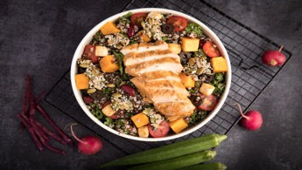
** The date and time of the operation of the units are determined by the hotel management according to seasonal conditions
BEACH CLUB SNACK BAR

Opening Hours:

Bar: 09:00 - 18:00

Lunch (Snack) : 12:00 – 16:00 Capacity:105 pax

Set on the Sunwing Side Beach private beach and surrounded by the deep blue of Side, you can add new memories at the Beach Bar. With the rippling sounds of waves, a unique view over the sandy beach, and the energy of the sun, you will cherish the moment while sipping a refreshing drink.The snack service,beer,wine,and soft drinks are for free for all inclusive guest.

SPORTS BAR
Opening Hours : 10:00 – 00:00 Capacity:102 pax
The Sports Bar offers a menu of rich options, including local and foreign drinks, special cocktails, and delicious snacks. Offering pleasant options for guests around the pool, the bar also features TVs with sports games, as well as a complimentary ice cream service for all-inclusive guests from 10:30 until 22:00.

JOS BAR
Opening Hours : 10:00 – 18:00
In addition to a wide range of ice cream flavours that you can enjoy at any time of the day, this corner offers a scrumptious waffle and pancake service! Cool off in the summer heat with fresh-squeezed fruit juices, smoothies, or your favourite sparkling drink!Subject to charge for all our guest.

***The facility shall remain entitled to modify the service concept as based on the resolutions adopted by the World Health Organization, the Ministry of Culture and Tourism of the Republic of Turkey
and the Ministry of Health of the Republic of Turkey and also the local authorities during the course of the normalization process implemented with respect to the Covid-19 by the Ministry of Culture and Tourism of the Republic of Turkey

BARY STAR CONCEPT (0 – 2 years old) **

We supply all the items we’d need for our own children with the Bary star application. We want you to know that we believe that the children are also our responsibility: this application ensures you do not have to carry all the equipment that makes life easier for the little ones.

Our free services include buggies, cots, baby monitors, bouncy chairs, high chairs, bibs, bottle warmers, kettles, milk, baby baths, potties, baby toilet lids, changing mats, wet wipes. To take advantage of the Barystar privileges, please inform our staff at booking. All the necessary equipment will be provided free of charge throughout your stay, once you inform us. You can also find baby food and nappies at the hotel supermarket.

Miniclub (For between 3-7 years old)

Opening Hours: 10:00 – 12:00 and 14:30 – 17:00

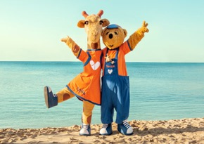

- The date and time of the operation of the units are determined by the hotel management according to seasonal conditions.

HONEYMOON CONCEPT

On the day of check-in;

- Luxury Fruit Basquet

- Sparkling Wine

- Bathrobes and slippers
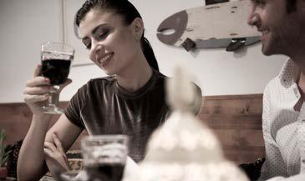
OTHER SERVICES

FREE SERVICES

- Safety Box (in the rooms)

- Towels, umbrellas, sunbeds at the pool and the beach

- Mini Club (4-12 years)

- Baby Lounge

- Kids Movie Room

- Daily Animation and Sport Activities

- Aerobic / Gym & Step

- Fitness Center

- Hamam

- Iron & Iron Board(On Request)

- Table Tennis

- Tennis Court

- Bathrobe, Slipper, Kettle

- Water Slides

- Play Ground(For Kids)

- Beachvolley

- Wi-Fi
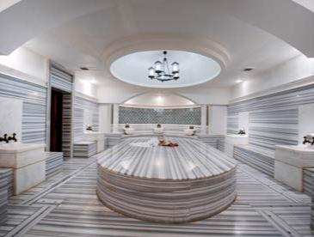

PAID SERVICES

- Car Rental Service

- Doctor & Nurse

- Photograph

- Laundry&Dry Clean Service

- Telephone and Fax

- Market, Boutique, Shoe Store

- Hairdresser

- SPA Services/ COVID – 19 SPA SERVICE CONSENTATION IS RECEIVED FROM THE GUEST FOR THE COVID – 19 GENERAL OF THE MINISTRY OF CULTURE AND TOURISM.

- Massage – Scrub

- Water Sports

- Billiards

- Tennis Racket ve Balls

***The facility shall remain entitled to modify the service concept as based on the re solutions adopted by the World Health Organization, the Ministry of Culture and Tourism of the Republic of Turkey and the Ministry of Health of the Republic of Turkey and also the local authorities during the course of the normalization process implemented with respect to the Covid-19 by the Ministry of Culture and Tourism of the Republic of Turkey.

AWARDS AND CERTIFICATES

AWARDS AND CERTIFICA

- Travel Life Gold :2013-2015
- Travel Life Gold :2015-2017
- Travel Life Gold :2017-2019
- Travel Life Gold :2019-2021
- EU ECOLABEL CERTİFİED
- TRIPADVISOR Excellence 2014
- TRIPADVISOR Excellence 2015

THE MINISTRY OF CULTURE AND TOURISM COVID – 19 WHICH THE MINISTRY OF HEALTH AND THE LOCAL AUTHORITIES REQUIRED IN THE NORMALIZATION PROCESS; RESERVES THE RIGHT TO VARIABILITY IN THE SERVICE APPROACH.

- Officially certified first class products and brands are used in all food and service offerings.
- Guests who are allergic to any food are informed by filling the allergen forms at the front desk.
- Allergen monitoring is the responsibility of the individual. Hotel management is not responsible for any problems that may arise in guests who have not been registered.
- According to the Turkish laws dated 19.05.2008, it is forbidden to smoke in closed areas open to general use.
- Pets are not accepted in our facility.
- Hotel check-in time is 14.00 and check-out time is 12.00.
- Dress code is applied in restaurants and bars in the hotel.
- Outdoor activities and organizations may vary depending on the weather opposition.
- Heated pools are heated in April, May and October according to the weather conditions in line with the decision of the hotel management.
- Under the TC Pool Regulations Laws, indoor pools are heated in the range of 26-28 degrees.
- On which days restaurants and bars will be closed may vary depending on the weather conditions and reservation requests of the hotel management.
- Hotel management reserves the right to make unilateral variation regarding the services and information in this guide.
- T. C. All the proposals submitted by the Ministry of Tourism will be applied to the guests by the enterprise.

***The facility shall remain entitled to modify the service concept as based on the re solutions adopted by the World Health Organization, the Ministry of Culture and Tourism of the Republic of Turkey and the Ministry of Health of the Republic of Turkey and also the local authorities during the course of the normalization process implemented with respect to the Covid-19 by the Ministry of Culture and Tourism of the Republic of Turkey.

