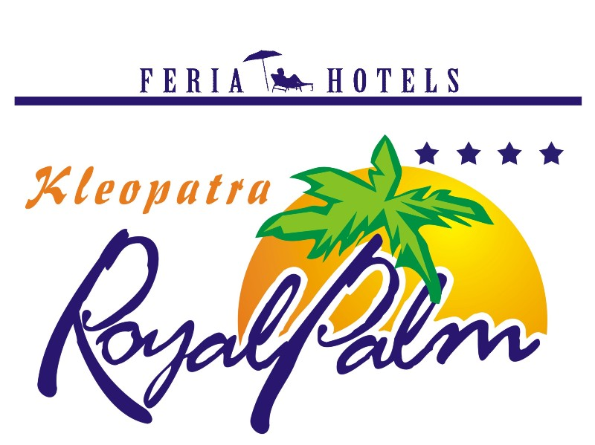

KLEOPATRA ROYAL PALM HOTEL **** ALANYA – ANTALYA, TURKEY

MORE INFORMATION

Check-in Time | 14:00
Check-out Time | 12:00
Number Of Floors | 5
Number Of Rooms | 233
Number Of Family rooms | 53
Year Of Construction | 2003
Last Renovation | 2016
Address | Ataturk cad. Kızlarpınarı Mah. H. Şenli Sok.no:3/A , Alanya – Antalya
Tel | 0 242 511 95 17
Fax | 0 242 512 82 39
E-mail | sales@feriahotels.com
Web Site | www.feriahotels.com

CONTACTS

Title | Mr.
First Name | Cemal
Last Name | Ceylan
Position | Sales & Marketing Manager
Phone | 0 242 511 95 17
Fax | 0 242 512 82 39
E-mail | sales@feriahotels.com
Address | Kızlarpınarı Mah.Ataturk cad. H.Şenli sok. Emniyet Md. Yani, Alanya – Antalya
City | Antalya
Zip code | 07400
Country | Turkey

GENERAL HOTEL INFORMATION

Royal Palm Hotel is located in Kleopatra beach; it takes 1 km to Alanya Centrum, 50 m to the beach, 118 km to Antalya Airport.
Taxi and minibus are available for your transportation.
Address: Ataturk cad. Emniyet Md.yani, Alanya – Antalya / Turkey

ROOMS

Standard Rooms
Rooms are about 24 m2 and have ceramic flooring. They have a bedroom including split air condition, satellite TV, music channel, safe box (with extra charge), telephone, mini bar (with extra charge), a bathroom including shower, WC and hair dryer, a balcony. They have minimum 2 pax and maximum 2⁺ 1 capacities. Room service is also available between 08:00 – 24:00.

Family Rooms
Rooms are about 30 m2 and have ceramic flooring. They have one bedroom and one living room including split air condition, satellite TV, music channel, safe box (with extra charge), telephone, mini bar (with extra charge), a bathroom including shower, WC and hair dryer, a balcony. They have maximum 4 pax capacities. Room service is also available between 08:00 – 24:00.

AMENITIES

Features (free of charge)

Outdoor Swimming Pool

Outdoor Kids’ Pool
Baby cot
Kids’ Playground
Sun beds (by the pool)
Sun umbrellas (by the pool)
Mattress (by the pool)
Sea (sandy)
Beach (sandy)
Breakfast, lunch and dinner
Elevator

TV Hall
Aqua swimming pool
Info room 40 people capacity
Turkish bath

Sports & Activities

Table tennis, dart, billiards (with extra charge), Garden & Beach volley,
Sauna, massage, beauty centre (all with extra charge),

Entertainment

There are activities and entertainments for all ages, choices and culture in Kleopatra Royal Palm Hotel. Unlimited activities and entertainments are served by the animators who are expert and experienced in their branch. You may learn details of belly-dance or play garden & beach volley in our thin sand beach during the day.

Mini Club
Another privileged care of Royal Palm Hotel is to make our small guests of 4-12 years old feel as much safe and comfortable as they are at home with their parents in the mini club. They can play with toys and have fun.
BARS & SNACKS

Pool Bar
Service hours are between 10:00 and 00:00.
(All inclusive: 10:00-23:00 o’clock)
(It’s not allowed to serve alcohol drinks under 18 years old guests.)

Beach Bar
Service hours are between 08:00 and 17:00.

DINING

Restaurant

The restaurant has 180 pax indoor with air condition and 240 pax outdoor capacities.

Breakfast 08:00 – 10:00 (Buffet)
Snack 10:00 – 12:30 & 14:00 – 17:00 (Pool)
Lunch 12:30 – 14:00 (Buffet)
Café and cake 17:00 – 18:00 (Buffet)
Dinner 19:00 – 21:00 (Buffet)

GOOD TO KNOW

Not included in the Package
Doctor
Mini bar
Safe box
Sun beds (on the beach)
Sun umbrellas (on the beach)
Mattress (on the beach)
Sauna
Massage
Beauty centre
Water sports (on the beach)
Laundry
Wi-fi

