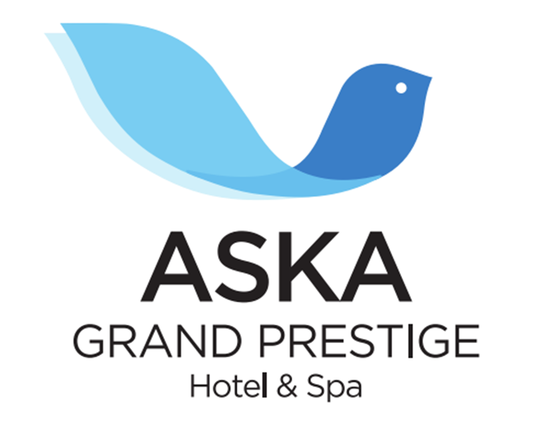

HOTEL INFORMATION

NAME OF THE HOTEL ASKA SİDE GRAND PRESTIGE HOTEL & SPA
MARKETING CATEGORY 5 STARS
ADDRESS TİTREYENGÖL CAD. 07600 MANAVGAT / ANTALYA
TELEPHONE +90 0 242 756 90 60
TELEFAX +90 0 242 756 90 80
WEB www.askahotels.com
E-MAIL grandprestige@askahotels.com
SALES & MARKETING Bünyamin VURAL
BOARD ULTRA ALL INCLUSIVE
PERIOD OF OPENING SUMMER SEASON
LANGUAGES GERMAN, ENGLISH, RUSSIAN
QUALITY SYSTEMS & CERTIFICATIONS BLUE FLAG

LOCATION & DISTANCES

HOTEL TO AIRPORT ANTALYA 69 KM
GAZİPAŞA 91 KM

NEAREST CITY ANTALYA 80 KM
MANAVGAT 6 KM
SIDE 7 KM
ALANYA 67 KM

SHOPPING CENTERS ANTALYA 80 KM
MANAVGAT 6 KM
ALANYA 67 KM

NEAREST HOSPITAL MANAVGAT 6 KM

BEACH EQUIPMENTS SUNBEDS AND UMBRELLAS

DISTANCE TO THE BEACH ON FIRST LINE, 250 METERS

DESCRIPTION OF HOTEL ON FIRST LINE

NUMBER OF ROOMS 346 ROOMS

NUMBER OF BEDS 732 BEDS

TRANSPORTATION

DOLMUSH (PUBLIC MIDI BUS), TAXI

ROOM FACILITIES

STANDART ROOM (22 m²) 1 FRENCH BED + SNG
1 FRENCH BED
TWIN BEDS
TRIPLE BEDS
KANGURU ROOM (22 m²) 1 FRENCH BED + SLIDING BED
BUNKBED ROOM (22 m²) 1 FRENCH BED + BUNK BED
JUNIOR SUIT (37 m²) 1 BEDROOM (1 FRENCH BED) + 1 LIVING ROOM (2 COUCHES)
SENIOR SUIT (45 m²) 1 BEDROOM (1 FRENCH BED) + 1 LIVING ROOM (2 COUCHES)
HANDICAPPED ROOM (22 m²) 2 TWIN BEDS

ALL ROOMS ARE EQUIPPED WITH CARPET, SHOWER & WC, AIR CONDITION, TELEPHONE, HAIRDRYER, SATELLITE TV, MUSIC CHANNEL, MINIBAR, SAFE BOX AND BALCONY.

HOTEL ACTIVITIES

SWIMMING POOL
2 OUTDOOR POOLS
2 CHILDREN POOL
3 SLIDE POOLS (SLIDES FOR ADULTS)
2 SLIDE POOLS (CHILDREN SLIDES)

CONFERENCE ROOMS

2 ROOMS (1 FOR 100 PERSON, 1 FOR 200 PERSON)

SHOPPING CENTER

JEWELLERY, LEATHER SHOP, MARKET, BOUTIQUE, GIFT SHOP, HAIRDRESSER, DOCTOR, PHOTOGRAPHER

EXCLUDED-INCLUDED ACTIVITIES

INCLUDED ACTIVITIES
CONFERENCE ROOMS (EQUIPMENT NOT INCLUDED)
DISCO
ICE CREAM
TV ROOM
TABLE TENNIS - DART
MINIBAR (DAILY FILLED WITH WATER AND SOFT DRINKS)
AQUPARK (10:00-12:00 AND 14:00-17:00)
SUNBEDS & UMBRELLAS (AT THE POOL AND BEACH)
MINI CLUB-CHILDREN’S PLAY GROUND
BEACH VOLLEYBOL
INTERNET ACCESS (LOBBY)
BEACH/POOL TOWELS
ANIMATION ACTIVITIY
SPA CENTER (TURKISH BATH, SAUNA)

EXCLUDED ACTIVITES
BIRTHDAY & CELEBRATION PACKAGE
WIRELESS (IN THE ROOMS)
SPA (MASSAGE)
SAFE
MINI MARKET
HAIRDRESSER
FRESH PRESSED FRUIT JUICE
OUT OF CONCEPT SOME ALKOHOLIC DRINKS
TELEPHONE, PHOTOCOPY
DOCTOR SERVICE
RENT A CAR

CHILDREN ACTIVITIES

MINICLUB (4-12 AGES) (10:00-12:00 / 15:00-17:00)
CINEMA FOR CHILDREN (AT 14:00 O’CLOCK IN MINICLUB)
CHILDREN PLAYGROUND

RESTAURANTS AND BARS

RESTAURANT
BREAKFAST 07:00 – 10:00 BUFFET RESTAURANT
LATE BREAKFAST 10:00 – 10:30 MINI BUFFET RESTAURANT
LUNCH 12:30 – 14:00 BUFFET RESTAURANT
DINNER 19:00 – 21:00 BUFFET RESTAURANT
CHILDREN BUFFET 18:30 – 20:00 MINI BUFFET RESTAURANT
MIDNIGHT SOUP 00:00 – 01:00 BUFFET RESTAURANT

APPERATIVE SERVICE
SNACK BAR 12:00 – 16:00 FOOD COURT
PIZZA & PIDE CORNER 12:00 – 16.00 FOOD COURT
TURKISH PANCAKE (GOZLEME) 12:00 – 16:00 AT THE BEACH
BEACH SNACK BAR 12:00 – 16:00 AT THE BEACH
CAFE & BREAK HOUR 16:00 – 18:00 AT POOL BAR
ICE CREAM 12:30 – 14:00

A’ LA CARTE
TURKISH CUISINE (WITH RESERVATION, PER PERSON 10 EURO) SULTAN SOFRASI
ITALIAN RESTAURANT (WITH RESERVATION, PER PERSON 10 EURO) SULTAN SOFRASI

BARS SNACK BAR 12:00 - 16:00
LOBBY BAR 10:00 - 00:00
POOL BAR 10:00 - 00:00
BEACH BAR 10:00 - 17:00
NIAGARA DISCO 23:30 - 02:00

Our Honeymoon Package includes:
VALID FOR MINIMUM 7 NIGHTS STAYS
Special honeymoon room decoration
Complementary fruit basket & wine in the room
1 Time free a la carte with reservation

PROCEDURE FOR CHECK-IN / CHECK OUT
Check-in time is 14:00 and check-out time is 12:00 o’clock.

****THE SERVICES WE PROVIDE ACCORDING TO PANDEMIC CONDITIONS MAY BE CHANGED.

