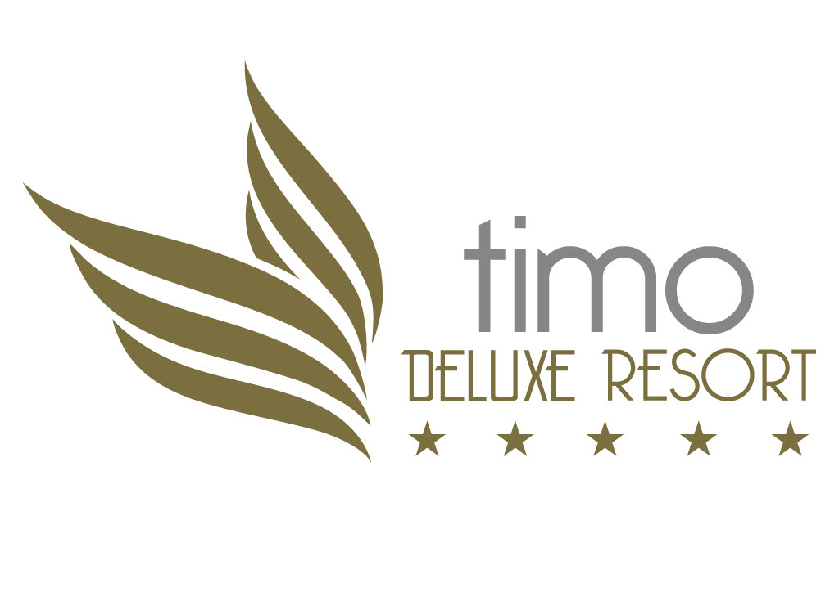

TİMO DELUXE RESORT DISPLAY INFORMATION

HOTEL NAME : TİMO DELUXE RESORT
OPERATOR FIRM : KURŞUN TURİZM İNŞ.SAN ve TİC A.Ş.
CATEGORY : 5 STARS
ADDRESS : KONAKLI MAH. MUSTAFA KEMAL BULV. NO-41
KONAKLI - ALANYA / ANTALYA
E-MAIL ADDRESS : info@hoteltimo.com.
WEBSITE : www.hoteltimo.com.
PHONE NUMBER : 00 90 242 565 20 51
FAX NUMBER : 00 90 242 565 20 51
AIRPORT CODE : AYT – ALANYA
SUMMER SEASON : 2023
CONCEPT : ULTRA ALl INCLUSIVE
HOTEL OPENING DATE : 2004
LATEST RENEWAL : 2021
ON SEASON : SEASONAL
HOTEL GENERAL MANAGER : CAN ÖZKAN
HOTEL AREA : 13.067 M2

FACILITY LOCATION : ON THE MAIN ROAD, 75M DISTANCE TO SAND-PEBBLE MIXED PRIVATE BEACH AVAILABLE THROUGH SPECIALLY DESIGNED UNDERPASS.

ANTALYA AIRPORT : 110 KM
GAZİPAŞA/ALANYA AIRPORT : 65 KM
ANTALYA CITY CENTER :120 KM
SİDE CITY CENTER : 55 KM
ALANYA CITY CENTER : 15 KM
KONAKLI CITY CENTER : 500 MT

TRANSPORTATION OPTIONS : TAXI-MINIBUS-BUS (BY THE HOTEL)
PARKING SPACE : AVAILABLE

DOCTOR AT HOTEL : DOCTOR AVAILABLE EVERYDAY AT CERTAIN HOURS
NURSE : NURSE AVAILABLE EVERYDAY AT CERTAIN HOURS
NEAREST HOSPITAL : 15 KM ALANYA
MEDICAL CLINIC : 200 METERS (KONAKLI)

FACILITY
TOTAL ROOM NUMBER : 251 ROOMS
TOTAL BED CAPACITY : 506 BEDS
ROOM TYPES : STANDART, FAMILY, SUITE, ROOM FOR HANDICAPPED
NUMBER OF BUILDINGS : 1 MAIN BUILDING (6 FLOORS)
NUMBER OF ELEVATORS : 4 GUEST + 3 PERSONNEL
ROOM FOR HANDICAPPED : 2 PRIVATE ROOMS
ROOM FOR NONSMOKERS : FIRST FLOOR, 24 ROOMS
PETS : NOT ALLOWED
CREDIT CARDS ACCEPTED : VISA – MASTER – EUROCARD
GARDEN LAYOUT : BOTANIC GARDEN AND WELL-GROOMED GARDEN
LANGUAGES SPOKEN : TURKISH, ENGLISH, GERMAN, RUSSIAN

ENVIRONMENTAL PROTECTION MEASURES
GREEN STARRED FACILITY
CENTRAL SYSTEM OF DECONTAMINATION (MUNICIPALITY)
SEPERATION OF WASTE
PRECAUTIONS AGAINST NOISE
REGULAR HYGIENE CONTROLS (ISIS)
WATER AND ENERGY SAVING PRECAUTIONS (ISIS)
USE OF ECOCREDENTIAL CHEMICALS
SECURITY PRECAUTIONS AND TEAM

ROOMS
ROOMS ARE DESIGNED MODERN AND SPACIOUS
STANDART ROOM :233
FAMILY ROOM :12
SUITE ROOMS : 3
KING SUITE : 1
HANDICAPPED ROOM : 2

ROOM FEATURES : STANDART ROOM FAMILY ROOM
M2 : 29 M2 32 M2
MINIMUM PERSON/ACCOM. : 1 1
MAXIMUM PERSON/ACCOM. : 3 + 2 4+1
ROOM WITH DIRECT SEA VIEW : X X
BALCONY WITH DIRECT SEA VIEW : X X
ROOMS WITH FOREST VIEW : X X
BALCONY : X (Some rooms French) X (French Balcony)
WC / BATHTUB : X X (Shower)
HAIR DRYER : X X
AIR CONDITIONER ( 24 HOURS) : X ( CENTRA ) X ( CENTRAL )
DIRECT TELEPHONE : X X
MUSIC CHANNEL ON TV : X X
SATELITE TV : X X
MINIBAR : X (C/in full, daily water) X (C/in full, daily water)
SERAMICS : X X
SAFE FOR RENT : X ( PAID ) X ( PAID )
CONVERTIBLE SOFA BED : X X

RESTAURANTS
1 – MAIN RESTAURANT : AIR CONDITIONED & OUTDOORS – NONSMOKING AREA
CAPACITY : INDOOR 350 PEOPLE – OUTDOOR 170 PEOPLE

2 – SNACK / POOL RESTAURANT : OUTDOORS
CAPACITY : OUTDOOR 175 PEOPLE

3 - MEDITERRANIEAN A LA CARTE : OUTDOORS – 75 PEOPLE ( PAID)

4 – OTTIMO A LA CARTE REST. : AIR CONDITIONED – 45 PEOPLE ( ITALIAN )

( A LA CARTE RESTAURANTS ARE IN SERVICE BETWEEN THE DATES 15.05.2022/15.10.2022. THE DATES ARE SUBJECT TO CHANGE BY THE HOTEL MANAGEMENT ACCORDING TO WEATHER CONDITIONS.)

BREAKFAST : OPEN BUFFET MAIN RESTAURANT
ÖĞLE YEMEĞİ : OPEN BUFFET MAIN RESTAURANT
AKŞAM YEMEĞİ : OPEN BUFFET MAIN RESTAURANT

BARS ( SELF SERVICE )
1- LOBBY BAR : HOURS : 10.00 – 24.00 AIRCONDITIONED
2- POOL BAR : HOURS: 10.00 – 24.00 OURDOORS
3- BEACH BAR : HOURS: 10.00 – 18.00 OUTDOORS
4- SERVICE BAR : HOURS: SERVICE HOURS
5- PUB BAR : HOURS: 22:00 – 10:00 AIRCONDITIONED
6- DISCO BAR : HOURS: 23:00 – 02:00 AIRCONDITIONED

ULTRA ALL INCLUSIVE CONCEPT
BEVERAGES : 24 HOURS ALL LOCAL ALCOHOL AND NONALCOHOL BEVERAGES, HOT BEVERAGES – NATURAL CONCENTRATE FRUIT JUICE – CONCEPT INTERNAL IMPORT ALCOHOL BEVERAGES (Viski,Malibu,Bacardi,Baileys,Campari )
: MINIBAR FILLED UPON CHECK-IN AND DAILY 1 BIG BOTTLE OF WATER (PER ROOM)

FOOD : 07.00 – 10.00 OPEN BUFFET BREAKFAST
. 10.00 – 10.30 BRUNCH
: 11.30 – 16.30 SNACK BAR/POL BAR
: 12.30 – 14.00 MAIN RESTAURANT LUNCH
: 17.00 – 17.30 COFFEE-BREAK
: 19.00 – 21.00 OPEN BUFFET DINNER
: 23.30 – 00.00 NIGHT SOUP
: 02:00 – 06:00 NIGHT BUFFET

PAID SERVICES AND ACTIVITIES : TURKISH COFFE
BOTTLED ALCOHOL OR NONALCOHOL BEVERAGES
SAFE FOR RENT
LAUNDRY AND IRONING
TELEPHONE– FAX
DOCTOR AND HEALTH SERVICES
SHOPPING CENTER – RENT A CAR- WATER SPORTS

SHOPPING CENTER (PAID)
BOUTIQUE
HAIRDRESSER
MINI-MARKET
PHOTOGRAPHER

ACTIVITIES
TURKISH BATH : FREE
SAUNA, STEAM BATH : FREE
BATHSCRUB, MASSAGE : PAID
FITNESS ROOM (SPORTS CENTER) : FREE
BILLARD : PAID
DART : FREE
TABLE TENNIS : FREE ( BALL AND RACKET)
BEACH VOLLEYBALL : FREE
BASKETBALL : FREE
LAUNDRY : PAID

TENNIS
TENİS KORTU : FREE – 1 HARD FLOOR TENNIS COURT
NIGHT LIGHTING PAID
BALL AND RACKET FREE

CONFERENCE & MEETING HALLS

1 – GROUND FLOOR : 350 M2
CAPACITY (PERSON) : 250 PEOPLE ( THEATER DESIGN )

SWIMMING POOLS
INDOOR SWIMMING POOL : 36, m x 12,m x 1 ,40 m)
: ÇOCUK KISMI VAR – DUŞ – WC – SOYUNMA KABİNİ
SUNBED / CUSHION : FREE

BEACH TOWEL : FREE

OUTDOOR POOL (RELAX) :600 m2

KIDS POOL : SEPERATED

OUTDOOR POOL (ACTIVITY) :300 m2

KIDS POOL : 80 m2 SEPERATED

AQUAPARK :3 SLIDES

BEACH
BEACH DEFINITION : SAND AND PEBBLE 60 mt WIDTH
SEA DEFINITION : SAND AND PEBBLE – DEEPENING CLOSE
SUNBED / CUSHION : FREE
SHADE / UMBRELLA : FREE
: SHOWER – WC – DRESSING CABIN
WATER SPORTS
PRIVATELY OWNED : PAID ( MOTOR WATER SPORTS)
WATER SKI : PAID
PARASAILING : PAID
BANANA : PAID
JET SKI : PAID

OTOMOBILE / MOTORCYCLE : RENT A CAR / PAID

ANIMATION & ENTERTAINMENT PROGRAM
ANIMATION TEAM : INTERNATIONAL LANGUAGE SPEAKING
EVENING ANIMATION PROGRAM : 6 DAYS A WEEK
DAY LONG ANIMATION : POOL AND BEACH GAMES – DAILY ACTIVITIES

KIDS
KIDS ANIMATION : 10:00/12:00 – 14:00/16:00
MINI CLUB : 4 – 12 YAŞ GRUBU ÇOCUKLAR İÇİN
KIDS PLAYGROUND : OUTDOORS
BABY BED : FREE

NOTE : THE PROGRAMS, SERVICES AND TIME PERIODS ARE SUBJECT TO CHANGE BY HOTEL MANAGEMENT IN ACCORDANCE WITH THE WEATHER CONDITIONS.

