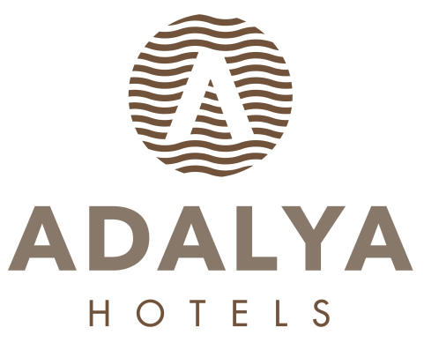
HOTEL FACT SHEET
- GENERAL INFORMATIONS:

HOTEL NAME : ADALYA ARTSİDE HOTEL
LOCATION : EVRENSEKİ
CATEGORY : 5 (Five) Stars Hotel
ADRESS : EVRENSEKİ BELDESİ MANAVGAT
TELEPHON : + 90. 242. 763 86 50 PBX
FAKS : + 90. 242. 763 86 62
WEB PAGE : www.adalyahotels.com

E-MAIL : info@adalyahotels.com

- HOTEL TRANSPORTATION:
TO DISTANCE METHOD DURATION
MANAVGAT CITY CENTER 15 km Bus / Taxi (+/-) 15 Min.

ANTALYA AIRPORT 60 km Taxi (+/-) 45 Min.

- ACCOMODATION:

TOTAL ROOM : 417 FLOORS : 5
TOTAL BED : 1181 LIFTS :5 ALL ROOMS ARE WITH:
OPENING YEAR : 2005 Telephon
LAST RENOVATION : 2019 Hot Drinks Set-Up
Wifi ( free)
Standart Double Rooms : 243 (+/- 29m²) (1 French + 1 Twin bed + sofa) LCD TV (Satellite)
Family Rooms ( Connection) : 139 (+/- 57m²) (1 French + 2 Twin bed) Mini bar
Standard Bunkbed Rooms : 31 (+/- 32m²) (1 French + 1 Bunkbed) Safe Box ( free)
Handicap Friendly Rooms : 4 (+/- 30m²) (1 French + 1 Twin bed) Balcony

- SPECIAL FEATURES::
Site Surface : 27.000 m² OPENING TIMES:
Outdoor Pool (open air) : 1.800 m² 08: 00 / 20: 00
Children Pool (open air) : 30 m² 08: 00 / 20: 00
Aquapark Pool (open air) : 48 m²
Aquapark Pool 2 (open air) : 95 m²
Indoor Pool works between 1.04- 31.05 : 226 m² with heating system. 09: 00 / 20: 00
Aqua Slides open : 3 Big Slides, 3 Small Slides ( works depending on weather conditions)
Main Restaurant (SULTAN) : 1095 m² Indoor Area (+/-) 600 person – 354 m² Outdoor Area (+/-) 350 person OPENING TIMES:
Divan A’la Carte Restaurant : 229 m² (+/-) 100 Person (Indoor) 19: 00 / 21: 00
Garda A’ la Carte Restaurant : 139 m² (+/-) 60 Person (Indoor) 19: 00 / 21: 00
Zhen Guen A’ la Carte Restaurant : 112 m² (+/-) 40 Person (Indoor) 19: 00 / 21: 00
Fish - A’la Carte Restaurant : 415 m² (+/-) 100 Person (Indoor) 01.06/15.10. Opening Dates 19: 00 / 21: 00
Lobby Bar : 367 m² (+/-) 140 Person (Indoor) 10:00- 24:00
Perge Bar 2 : 220 m² (+/-) 80 Person (Indoor) 24: 00 / 08: 00
Beach Bar : 415 m² (+/-) 100 Person (Outdoor) 10: 00 / 18: 00
Pool Bar : 418 m² (+/-) 200 Person (Outdoor) 10: 00 / 24: 00
Disco Bar : 420 m² (+/-) 300 Person (Indoor) 24: 00 / 03: 00
Amphi Bar 20: 00 / 23: 00
Patesseria : 131 m² (+/-) 50 Person (Indoor) 11: 00 / 22: 00
Game Hall : Billiards, Chess, Air hokey, Table soccer, Video games and Bowling (Extra charged)
Wellness, Beauty Center / SPA : Turkish Bath, Sauna, Special massages, SPA, VİP Massages,
Shopping Center : Jeweler shop, Market, Hair Dresser, Boutique, Leather shop, Silver Shop, Souvenier, Photo shop, Bag Shop..
Mini Club : 113 m² For children between 4 -12 ages
Seleuka Meeting Hall : 450 m². Theater Style 400 person
Meetin Hall 2 : 75 m². Theater Style 90 person
Meeting Equipment : Barcovision, Flip chart, Screen, Sound System, microphone system,
Cleaning Services : Daily Room cleaning and Towel change available.
Beach : 300 meter distance to the beach, Sand & Pebble mixed has Blue Flag Certification, it is a private beach.

- SPORT, FUN, HEALTH & BEAUTY SERVICES:

Extra Charged Free of Charge
* Billard * Daily Activities (Special Games)
* Bowling * Fitness Center
* Video games * Animation Shows
* Massage & Peeling * Special Gala Party, 1 time in every 2 weeks
* Facial treatment * Step, Aerobic, Gymnastics, Water Gym
* Friseur * Trampolin
* Beauty Center * Squash, Tennis (lighting extra charged)
* Water Sports on the beach (Parashute, Boat, Cano, Wind Surf * Table Tennis, Dart, Beach Volley, Boccia

- GUESTSERVICES :

Extra Charged : Free of Charge :
* Doctor * Turkish bath, Sauna,
* Jeep, car rental, Bicycle and baby care rental * Mini Library
* Shopping center * WiFi
* Airport Transfer * Mattress and Umbrellas at the Beach and Pool
* Laundry * Beach Towel * * Telephone and fax * Mini Club between 4–12 old kids, Mini disco
* Safe Box (room)

- USEFULL INFORMATIONS:

*** Use full Credit Cards : Visa, Master card, Maestro card,
*** Languages : Turkish is the official language. German, English and Russian are spoken
*** PETS ARE NOT ALLOWED.

