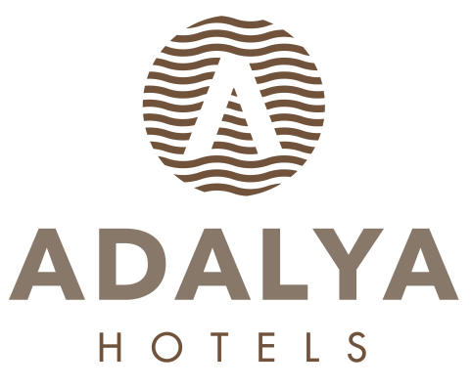

ADALYA ART SIDE HOTEL

ULTRA ALL INCLUSIVE SUMMER SEASON
FOOD & BEVERAGE CONCEPT

BREAKFAST 07: 00 - 10: 00 SULTAN MAIN RESTAURANT OPEN BUFFET
LATE BREAKFAST 10: 00 - 11: 00 SULTAN MAIN RESTAURANT OPEN BUFFET
LUNCH 12: 30 - 14: 30 SULTAN MAIN RESTAURANT OPEN BUFFET
DINNER 19: 00 - 21: 00 SULTAN MAIN RESTAURANT OPEN BUFFET + KIDS BUFFET
MIDNIGHT BUFFET 23: 00 - 07: 00 SULTAN MAIN RESTAURANT MINI OPEN BUFFET

SNACKS

POOL SNACK BAR 12: 30 - 16: 00 POOL SNACK RESTAURANT MINI OPEN BUFFET & FAST FOOD
BEACH SNACK BAR 12: 30 - 16: 00 BEACH SNACK RESTAURANT MINI OPEN BUFFET & FAST FOOD
PASTRY 10: 00 - 19: 00 PATESSERIA DRY AND WET BAKERY & ICE CREAM
ICE CREAM 12: 30 - 16: 00 PATESSERIA
ICE CREAM 18: 00 - 21: 00 PATESSERIA
FLAT-BREAD 12: 30 - 16: 00 POOL AND BEACH SNACK BAR
WAFFLE 12: 30 - 16: 00 WAFFLE CORNER ON THE BEACH
DONER 12: 30 - 17: 00 DONER CORNER ON THE BEACH

A’LA CARTE RESTAURANTS

OTTOMAN A’LA CARTE. 19: 00 - 21: 00 SPECIAL MENU OTTOMAN CUISINE RESERVATION
ITALIEN A’LA CARTE 19: 00 - 21: 00 SPECIAL MENU ITALIAN CUISINE RESERVATION
CHINA A’LA CARTE 19: 00 - 21: 00 SPECIAL MENU FAREAST CUISINE RESERVATION
FISCH A’LA CARTE 19: 00 - 21: 00 SPECIAL MENU SEA FOOD RESERVATION
*** Fish Ala Carte Restaurant serve between 01.06 / 15.10.

BAR

LOBBY BAR 10: 00 - 24: 00 LOCAL ALCOHOLIC / NONALCOHOLIC AND SOME IMPORT DRINKS
PERGE BAR 24: 00 - 08: 00 LOCAL ALCOHOLIC / NONALCOHOLIC AND SOME IMPORT DRINKS
POOL BAR 10: 00 - 24: 00 LOCAL ALCOHOLIC / NONALCOHOLIC AND SOME IMPORT DRINKS
BEACH BAR 10: 00 - 18: 00 LOCAL ALCOHOLIC / NONALCOHOLIC AND SOME IMPORT DRINKS
AMPHI BAR 20: 00 - 23: 00 LOCAL ALCOHOLIC / NONALCOHOLIC AND SOME IMPORT DRINKS
DISCO 24: 00 - 03: 00 LOCAL ALCOHOLIC / NONALCOHOLIC AND SOME IMPORT DRINKS 3 NIGHT IN A WEEK (INSIDE)
MINI BAR ON ARRIVAL MINIBAR IS FILLED WITH: COCA –COLA, FANTA, BEER,
MINERAL WATER, WATER, FRUIT JUICE
DAILY FILLED WITH WATER, MINERAL WATER, FRUIT JUICE

**************************************************************************************************

- IN ALL INCLUSIVE CONCEPT ALL DRINKS ARE SERVED IN GLASS

- BOTTLE DRINKS WILL BE CHARGED.

- ALCOHOL WILL NOT BE SERVED TO PERSONS UNDER AGE OF 18.

- FOR 7 NIGHTS ACCOMODATION 1 TIME 1 RESTAUTANT A LA CARTE IS FREE OF CHARGE WITH THE PRE RESERVATION

- PETS ARE NOT ALLOWED.

- FISH RESTAURANT WILL BE OPEN BETWEEN 01.06 / 15.10. (DEPENDING ON THE WEATHER CONDITION)

- DEPENDING ON WEATHER CONDITIONS HOTEL RESERVES THE RIGHT TO CHANGE DATE, PLACE AND TIME OF OUTLETS.

