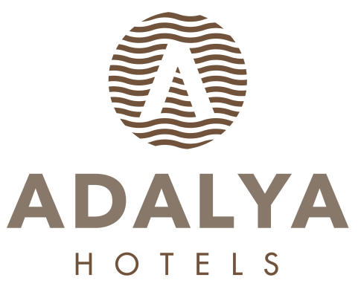
HOTEL FACT SHEET

- GENERAL INFORMATIONS:

HOTEL NAME : ADALYA RESORT & SPA HOTEL +16 ADULTS ONLY
LOCATION : EVRENSEKİ TURİZM MERKEZİ
KATEGORIE : 5 (FIVE) STARS HOTEL
ADRESSE : EVRENSEKİ / MANAVGAT / ANTALYA
TELEPHON : + 90 242 763 05 60 pbx
FAKS : + 90 242 763 04 16
WEB PAGE : www.adalyahotels.com

E-MAIL : info@adalyaresort.com

CONCEPT: : +16 (ADULTS ONLY)

- HOTEL TRANSPORTATION:
TO DISTANCE METHOD DURATION
SİDE CITY CENTER 10 km Shuttlebus / Taxi (+/-) 20 Min.
MANAVGAT CITY CENTER 12 km Shuttlebus / Taxi (+/-) 20 Min.

ANTALYA AIRPORT 65 km Taxi (+/-) 55 Min.

- ACCOMODATION:

TOTAL ROOM : 210 FLOORS : 5 ALL ROOMS ARE WITH:
TOTAL BED : 460 LIFTS :2 Telephone
OPENING YEAR : 2009 Wifi –free of charge
Hot Drinks Set-Up
Standard Double Rooms : 160 (+/- 30m²) (1- French Bed + 1-twinbed) LCD TV (Satellite)
Standard Double Rooms : 23 (+/- 30m²) (1- French bed or 2-twinbed) Mini bar
Family Rooms : 20 (+/- 40m²) (1- French bed + 1-twinbed) Safe Box(free of charge)
Handicap Friendly Rooms : 2 (+/- 30m²) (1- French bed + 1-twinbed) Balcony
Standart Superior Comfort Rooms (summer) : 5 (+/- 30m²) (1- French Bed + 1-twinbed)

- SPECIAL FEATURES:

Site Surface : 13.000 m² OPENING TIMES:
Outdoor Pool (open) summer : 480 m² 07: 00 / 20: 00
Indoor Pool winter : 80 m² WITH HEATING SYSTEM 08: 00 / 19: 00
Relax Pool (open) summer : 153 m² 07: 00 / 20: 00
Main Restaurant : 882 m² Indoor (+/-) 300 Person – Outdoor (+/-) 150 Person OPENING TIMES:
Ottoman A’la Carte Restaurant : 120 m² (+/-) 55 Persons 19: 00 / 21: 00
Steak House A’la Carte Restaurant : 72 m² (+/-) 30 Persons extra charge 19: 00 / 21: 00
Italian A la Carte Restaurant : 100 m² (+/-) 40 kişilik 19: 00 / 21: 00
Fish A la Carte Restaurant : 100 m² (+/-) 40 kişilik 19: 00 / 21: 00
Patesseria : 400 m² (+/-) 150 Persons 10: 00 / 19: 00
Lobby Bar : 195 m² (+/-) 250 Persons (outdoor) (+/-) 150 Personen teras 10: 00 / 24: 00
Pool bar summer : 165 m² (+/-) 100 Persons 10: 00 / 24: 00
Beach Bar summer : 208 m² (+/-) 150 Persons 10: 00 / 18: 00
Buhara Bar : 275 m² (+/-) 200 Persons 24 Hours
Disco Bar : 144 m² (+/-) 100 Persons 24: 00 / 03: 00
Hangout ( coffe house) : 20 m² (+/-) 20 Persons 10: 00 / 16: 00
Wellness, Beauty Center / SPA : 600 m² Turkish Bath, Sauna, Special massages, SPA, VİP Massages
Shopping Center : Jeweler shop, Market, Hair Dresser, Boutique, Leather shop, Silver Shop, Souvenier, Photo shop, Bag Shop.
Fergano Meeting Hall : 630 m² (+/-) 400 Person
Meeting Room : 75 m² (+/-) 50 Person
Cleaning Services : Daily Room cleaning and Towel change available.
Beach : 100 meter distance to the beach, Sand & Pebble mixed has Blue Flag Certification, it is a private beach

- SPORT, FUN, HEALTH & BEAUTY SERVICES:

Extra Charged Free of Charge
* Massage & Peeling – Foam * Daily Activities
* Skin Care * Animation Shows
* Hair Dresser * Fitness Center
* Beauty center * Special Gala Party, 1 time in every 2 weeks
* Water Sports in Beach (Parachute, Boat, Cano, Wind Surf * Turkish bath, Sauna,
* Table Tennis, Dart, Beach Volley, Boccia
* Aerobic, Gymnastics, Water Gym

- GUESTSERVICES :

Extra Charged Free of Charge

* Doctor * Animation Show
* Jeep, car rental, Bicycle rental * Mini Library
* Shopping center * Wireless in all Hotel areas free of charge, Rooms
* Airport Transfer * Mattress and Umbrellas at the Beach and Pool
* Laundry * Beach Towel
* Telephone and fax * Safe Box
* Room Services

- USEFULL INFORMATIONS:

*** Use full Credit Cards : Visa, Master card, maestro card,
*** Languages : Turkish is the official language. German, English and Russian are spoken
*** PETS ARE NOT ALLOWED.

