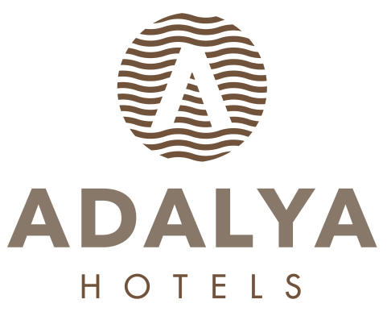

ADALYA RESORT & SPA +16 ADULTS ONLY

ULTRA ALL INCLUSIVE SUMMER SEASON
FOOD & BEVERAGE CONCEPT

BREAKFAST 07: 00 - 10: 00 HIVA MAIN RESTAURANT OPEN BUFFET
LATE BREAKFAST 10: 00 - 11: 00 HIVA MAIN RESTAURANT OPEN BUFFET
LUNCH 12: 30 - 14: 30 HIVA MAIN RESTAURANT OPEN BUFFET
DINNER 19: 00 - 21: 00 HIVA MAIN RESTAURANT OPEN BUFFET
MIDNIGHT BUFFET 21: 30 - 07: 00 TUĞRA RESTAURANT MINI BUFFET

POOL SNACK BAR 12: 30 - 16: 00 POOL SNACK BAR A’LA CART
BEACH SNACK BAR 12: 30 - 15: 00 BEACH SNACK BAR A’LA CART
PATISSERIE 10: 00 - 19: 00 PATISSERI DRY AND WET BAKERY & ICE CREAM
ICE CREAM 12: 30 - 16: 00 POOL BAR
ICE CREAM 12: 30 - 16: 00 BEACH BAR
FLAT-BREAD 11: 00 - 16: 00 BEACH BAR
WAFFLE 15: 30 - 16: 00 BEACH BAR WITH OPEN ICE
BAKED POTATOES 12: 30 - 16: 00 POOL BAR
DONER 12: 30 - 17: 00 BEACH BAR

A’LA CARTE RESTAURANTS

TUĞRA A’LA CARTE. 19: 00 - 21: 00 SPECIAL MENU OTTOMAN CUISINE RESERVATION
ITALIAN A’LA CARTE 19: 00 - 21: 00 SPECIAL MENU ITALIAN CUISINE RESERVATION
FISH A’LA CARTE 19: 00 - 21: 00 SPECIAL MENU SEA FOOD RESERVATION
STEAK HOUSE A’LA CARTE 19: 00 - 21: 00 SPECIAL MENU MEAT RESERVATION (EXTRA CHARGED)

BARS

LOBBY BAR 10: 00 - 24: 00 ALL LOCAL & SOME IMPORT ALCOHOLIC-NONALCOHOLIC DRINKS
BUHARA BAR 24 HOURS ALL LOCAL & SOME IMPORT ALCOHOLIC-NONALCOHOLIC DRINKS
POOL BAR 10: 00 - 24: 00 ALL LOCAL & SOME IMPORT ALCOHOLIC-NONALCOHOLIC DRINKS
BEACH BAR 10: 00 - 18: 00 ALL LOCAL & SOME IMPORT ALCOHOLIC-NONALCOHOLIC DRINKS
DISCO BAR 24: 00 - 03: 00 ALL LOCAL & SOME IMPORT ALCOHOLIC-NONALCOHOLIC DRINKS 3 NIGHTS A WEEK IN OCEAN DELUXE
HANGOUT ( COFFEE HOUSE) 10:00 -16:00
MINI BAR DAILY FILLED WITH SOFT DRINKS AND BEER
ROOM SERVICE 24 HOURS ALL FOOD & BEVERAGE EXTRA CHARGED.

**************************************************************************************************

- IN ULTRA ALL INCLUSIVE CONCEPT ALL DRINKS ARE SERVED IN GLASS

- BOTTLE DRINKS WILL BE CHARGED.

- ROOM SERVICE IS EXTRA CHARGED.

- DURING YOUR ACCOMMODATION WITH RESEVERTION IN ADVANCE 1 A’LA CARTE RESTAURANT ONCE IS FREE OF CHARGE

- PETS ARE NOT ALLOWED.

- SEAFOOD RESTAURANT WILL BE OPEN BETWEEN 01.06 / 15.10.

- DEPENDING ON WEATHER CONDITIONS HOTEL RESERVES THE RIGHT TO CHANGE DATE, PLACE AND TIME OF OUTLETS.

