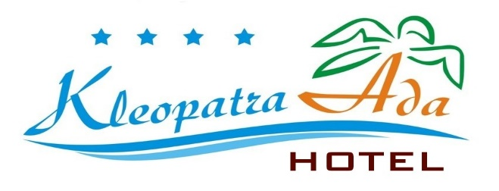
KLEOPATRA ADA HOTEL **** ALANYA – ANTALYA, TURKEY

2024 SUMMER HOTEL INFORMATION
Stars |  | 4 Stars
Check-in Time |  | 14:00
Check-out Time |  | 12:00
Number Of Floors |  | 5
Number Of Rooms |  | 123
Number Of Family Rooms |  | 23
Year Of Construction |  | 1996
Last Renovation |  | 2021
Address |  | Kızlar Pınarı Mah. Fatihler Sok. No:12 Alanya – Antalya
Tel |  | 0 242 512 87 44
Fax |  | 0 242 513 56 67
E-mail |  | info@kleopatraadahotel.com
Web Site |  | www.kleopatraadahotel.com
City | Antalya
Zip code | 07400
Country | Turkey

GENERAL HOTEL INFORMATION

Kleopatra Ada Hotel is located in Kleopatra beach; it takes 1 km to Alanya center, 70 m to the beach, 118 km to Antalya Airport and 400 mt to Alanya Bus Station. away.
Taxi and minibus and public bus are available for your transportation.
The hotel has 123 rooms including 280 beds totally.

Address: Kizlar Pınarı Mah. Fatihler Sok.. No:12 Alanya – Antalya / Turkey

ROOMS

Standard Rooms
Rooms are about 20 m2 and ceramic flooring. They have a bedroom including split air condition, satellite TV, safe box (with extra charge), telephone, mini bar (empty), a bathroom including shower, WC and hair dryer, a balcony. They have minimum 2 pax and maximum 3 pax capacities.

Family Rooms
Rooms are about 40 m2 and have ceramic flooring. They have two bedrooms. including split air condition, satellite TV, safe box (with extra charge), telephone, mini bar (empty), a bathroom including shower, WC and hair dryer, a balcony. They have maximum 5 pax capacities.
AMENITIES
Features (free of charge)

Outdoor Swimming Pool

Outdoor Kids’ Pool
Baby cot
Kids’ Playground
Sun beds (by the pool)
Sun umbrellas (by the pool)
Mattress (by the pool)
Sea (sandy)
Beach (sandy)
Breakfast, lunch and dinner
Elevator

TV Hall

Sports & Activities
Internet (with extra charge)
Billiards (with extra charge)
Sauna, massage, beauty centre (all with extra charge),
Water Sports (all with extra charge),
Turkish bath (entrance, free of charge)
Dart (free of charge)
Table tennis (free of charge)
Fitness room (free of charge)
Animations and shows (one times in a week, free of charge)

BARS & SNACKS
Service hours are between 10:00 and 22:00.
(All inclusive: 10:00-22:00 o’clock)
It’s not allowed to serve alcohol drinks under 18 years old guests.

Beach Bar
Service hours are between 08:00 and 17:00.

DINING

Restaurant
The restaurant has 120 pax, and 180 pax outdoor capacities.

Breakfast 08:00 – 09:30 (buffet)
Late breakfast 09:30 – 10:00 (buffet)
Lunch 12:30 – 14:00 (buffet)
Cafe and cake 17:00 – 18:00 (buffet)
Dinner 19:00 – 21:00 (open buffet)

GOOD TO KNOW

Not included in the Package (all with an extra charge)

Internet (with extra charge)
Doctor
Safe box
Sun beds (on the beach)
Sun umbrellas (on the beach)
Mattress (on the beach)
Food and Drinks on the Beach
Laundry
Telephone and fax
All fresh juices
Espresso, cappuccino and Turkish coffee
All import drinks (including Miller & Backs beer)

